

**Optical Communication networks**

**2nd simulation project**

**Introduction to OMNET++**

**Spring 2020**

**Project General Descriptions**

1. Create a network with an arbitrary name (example My_network).
2. Create the following topology with consideration of the mentioned condition.

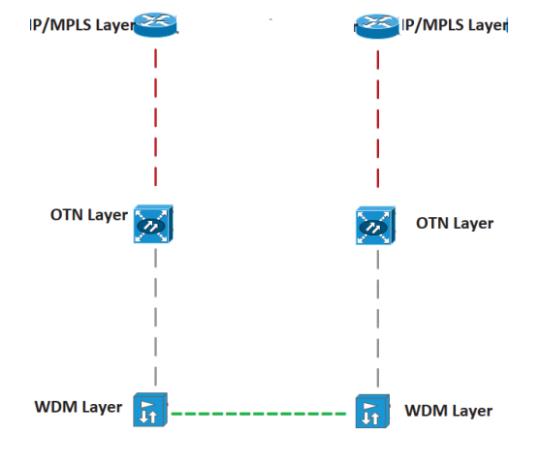

* Build a Compound Module with any arbitrary name (example My_node).
* Connect the Simple Modules as a layer structure with double-sided gates without delay.
* Connect DWDM layer gates to Compound Module gates without delay.
* Define two nodes of the Compound Module as an array and connect them with 50 milliseconds delay.
* Create an arbitrary packet (message).
* Node with the lowest index starts sending the packet to another node, each node when receiving the packet sends it to another.
* Every node, having received the packet, sends the packet to the highest layer (IP/MPLS).
* Define a variable in the packet and update the variable with the simulation time when the packet is sent down from the highest layer.
* Each layer, when receiving the package, should print a message denoting the packet received by this layer.

(The command for printing in omnet++ is EV << “Some Message!”).

* The highest layer, when received the packet, calculates and prints the elapsed time from receiving the packet to the time the highest layer of another node has started transmitting the packet.
* Define a random processing delay for each layer that is less than 50 milliseconds.
* The simulation must be stopped after exchanging 10 packets.
* Variables must be defined in the .ini file.

**How to hand in report**

The report should include descriptions of all the steps of the project implementation and images of the simulation environment. Upload zipped simulation files and the report (in .pdf format).